Pre-Registration for Healing of Memories Workshop

From Friday October 6 (5:00 pm) to Sunday October 8 2017 (3:00 pm)
at the Villa des Arts et l’Ermitage Sainte-Croix in Pierrefonds
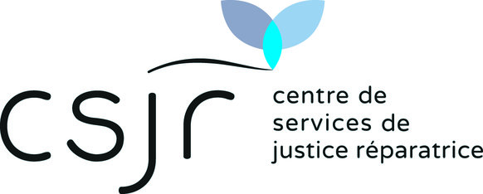

(Please complete all the spaces in blue.)
Coordinates
Family and given name:
Mailing Address :
E-mail :
Telephone Number(s) :
Why would you like to participate in this workshop?
Languages
I understand… |  |  |  |  |  |  |  | … le français |  |  |  | … English
I can express myself in… |  |  |  |  |  |  |  | … français |  |  |  | … English
My preference for speaking is… |  |  |  |  |  |  |  | … le français |  |  |  | … English
Ride-Sharing
 | I can take… |  |  |  |  |  | people in my vehicle.
 | I need a lift.
 |  |  |  |  |  | From what town/location?
The Cost of participation
The suggested financial contribution is $465: $300 for the workshop and $165 for meals and lodging with a single room and shared bathroom. To maximize the effectiveness of the workshop, it is essential that all the participants are resident in the Villa from the beginning to the end of the workshop.

The fees need only be paid when your registration is confirmed.

We do not want the level of the fees to prevent someone from participating in the workshop. If you have financial constraints please contact us and arrangements can be made.

If your financial circumstances permit, you may contribute an additional amount, in solidarity. This will help those with financial limitations to participate in the seminar.

Please send this completed form by e-mail to : csjr@csjr.org

Participation is limited to 16 people
More info?
http://www.csjr.org/en/healing-of-memories-workshop/
514-933-3737

